

Creativity using the Crazy Eight Technique
Name: Ajibola Abraham Olusola-oke
Supervisor: Bruce Power

A project report submitted in partial fulfilment for the degree of
MSc Computing
University of Lancashire

Introduction
The Crazy Eight exercise is a collaborative ideation technique popularized by Google Ventures, where each participants sketch eight distinct ideas in eight minutes using a writing tool and a paper folded into eight parts, this exercise will be followed by a convergence process where every team member will explain and select the best ideas. This ideation process is usually done in-person using a paper folded into eight parts and a writing tool, but all team members will have to be together physically in the same location.

However, as IT teams are increasingly working remotely from different locations, many organizations are moving their ideation practices into digital environments such as online whiteboards, web-based sketching tools and cloud document storages. This shift raises a crucial question: whether traditional paper Crazy Eight more effective than digital Crazy Eight? This project addresses the lack of research-based evidence on whether traditional paper-based Crazy Eight is more effective than digital Crazy Eight exercise. It investigates how the medium (either paper or digital) impacts the idea quality, collaboration and usability of Crazy Eight exercises. Not solving this problem will limit the practice of Crazy Eight Exercises to just teams that are on-site and there will be no digital solution that guides new participants on how they can effectively conduct a Crazy Eight exercise.

This project aims to provide solution to this problem by designing a custom digital Crazy Eight Web solution, and a detailed comparison of traditional paper and digital Crazy Eight exercise. The research includes both creative and non-creative participants, reflecting the core principle of rapid sketches of Crazy Eight.

The main research question is: Whether traditional paper-based Crazy Eight is more effective than digital Crazy Eight ideation for idea generation? To investigate this problem the aim of this project include:
1. Conduct comprehensive literature review examining the Crazy Eight technique, including its relationship to divergent and convergent thinking, design collaboration, constraints-based creativity, and rapid sketch prototyping.

2. Design Personas, user stories, wireframe and paper prototypes sketches for the preparation of the user-centred digital Crazy Eight solution.

3. Build a digital solution for Crazy Eight exercises, that users will be able to get text/voice-based instruction of Crazy Eight, timer count down, provide in-session tips on how to get the best out of the Crazy Eight ideation technique.

4. Test, analyse and evaluate the Web solution that it will be responsive on Desktop, mobile phones and tablets.

5. Collect and analyse data on completion rate and perceived idea quality, and usability using survey and experiments.

6. Collate the findings for comparison between physical and online/digital crazy eight exercise to reveal their strengths, weaknesses and when to effectively know their use-case.

The requirement for this digital Crazy Eight includes: Must have – an eight minutes count down with clear display of each one minute section, users must be able to restart the exercise at any point of the project, an on-screen guidance, an onboarding screen; Should have – Minimal distraction-free user interface, Voice guidance option to switch on or off; Could have – Light mode/ Dark mode, digital sketching area; Won’t have – collect and store user’s sketches, real-time multi-user collaboration, complex analytic dashboards. The non-functional requirements will include a minimalistic style with less distractions, and responsive layout for mobile, tablet, and large screen devices to make it accessible to many users.

State of the Art
This literary review examines the existing knowledge in the field of Crazy Eight, including major concepts that are crucial to the ideation technique, while also addressing the paper-versus-digital debate for ideation. The review combines literatures from creativity theory, divergent and convergent theories, effect of time constraint on creativity, rapid prototype sketching and digital collaboration for distributed teams. These creativity theories help us dive deep into why Crazy Eight technique has been so effective for ideation.

Additionally, this paper will investigate the question of whether traditional paper-based Crazy Eight exercises is more effective than digital execution of the ideation exercise, or whether digital Crazy Eight will offer more accessibility and enhance idea creation for contemporary teams. This work will also identify knowledge gaps in the field and provide foundational research for Crazy Eight execution.

Divergence and Convergence for Creativity
Creativity in this literature refers to innovation and the effectiveness of ideas, which means the creative solution needs to be new(novelty) but also useful in practice. Creativity research usually involves divergent thinking (the generation of several ideas), and convergent thinking (the collation and evaluation of multiple ideas). Runco and Acar's (2012) argue that divergent thinking as a reliable predictor of creative potential, in which there is a correlation between the quantity of ideas generated and originality (novelty of ideas), using fluency and originality score. Their research reveal that individuals who produce more ideas during the divergent phases generate more high-quality creative solutions, supporting the rapid ideation techniques like Crazy Eight that forces out eight distinct ideas during the divergent stage from each team member. As shown below in figure one.

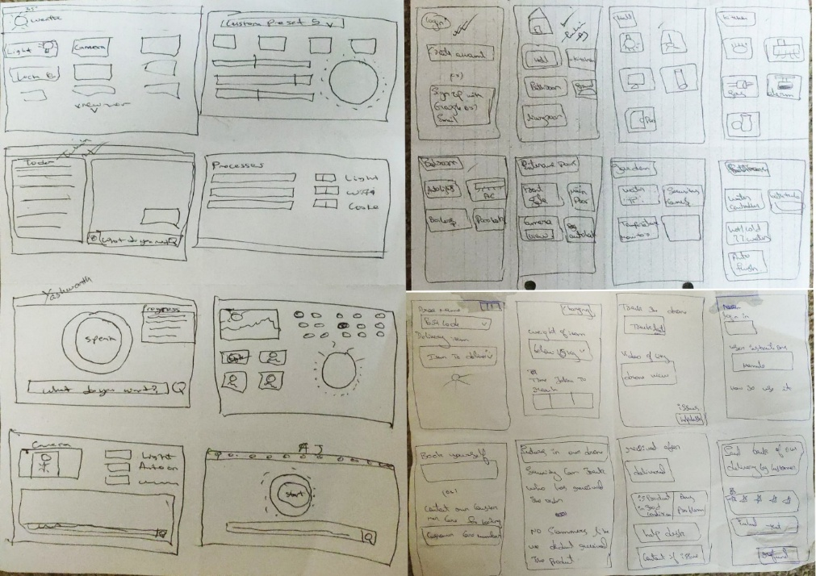

Figure 1: Crazy Eight Ideation exercise for Soratech Home Device UI Interface

However, Cropley (2006) emphasize on the importance of convergence. That convergent thinking is usually undervalued in the creativity process, which proves equally essential for innovation because effective design requires not only generation of several ideas but also adequate collation and refinement of the ideas, to select the ideas with genuine potential. The crazy eight technique separates the divergent phase from the convergent phase to make participants to focus on one at a time, while reflecting the importance of both. This practise prevents early convergence, which results into premature judgement limiting the generation of new ideas.

Within UI/UX contexts specifically, Biskjaer et al. (2017) reveal that premature convergence during idea generation phase limits the ideation diversity. Teams that maintained disciplined divergence before transitioning to evaluative phases produced more varied solution concepts. Additionally, their research identifies that structured creativity methods, including time-boxing exercises, help teams maintain appropriate separation between divergent and convergent phase.

Time Constraint
The word “Crazy” in Crazy Eight refers to the time constraint in the exercise. The time constraint pushes idea generation beyond the obvious ideas, as seen in figure one the first two ideas of participants were basic. Rosso (2014) stands to challenge the assumption that time freedom enhances creativity by showing that certain constraints can be enabling rather than restrictive. Rosso identifies that with supportive teams, constraints can focus attention, reduce search space, and push teams beyond their comfortable solutions, which will enhance creative outcomes. This resonates strongly with Crazy Eight ideas in eight minutes tight time limits and fixed “eight ideas” structure, which function as deliberately enabling constraints in early‑stage ideation.

Sowden and Dawson's (2011) experimental work examining time pressure's effects on creative performance reveals a delicate relationship between deadline pressure, emotional state, and ideation quality. Medium pressure can enhance team focus and output, whereas excessive pressure combined with negative mood will negatively affect originality of ideas produces by the team. Positive or activating mood state is important to get the most out an ideation technique like the Crazy Eight. The one-minute cycles are most effective when the tools have minimized unnecessary friction, keeping the experience urgent but playful rather than stressful.

Paper versus digital Crazy Eight
Amabile's (1983) theory of creativity provides a comprehensive framework for understanding how environmental factors, including choice of ideation medium, influences creative output. The theory posits three components: domain-relevant skills (expertise within a specific field), creativity-relevant processes (cognitive styles like habits and flexible thinking), and task motivation (intrinsic interest in the problem). This can be interpreted to the use of medium in Crazy Eight.

Despite much research on creativity, there is no research that directly compare paper and digital Crazy Eight ideation technique, but some discuss Crazy Eight among other ideation techniques. However, there are some studies that are related to the subject matter like Sturdee, Lewis and Marquardt that describe hand‑drawn sketches on paper as a quick and effective way to externalize mental models, also providing low commitment that promotes experimentation without any fear of wasted effort, and a level of ambiguity that invites reinterpretation and iteration. Like in figure 1, this low fidelity prototype style makes it perfect for the fast-paced interpretation of ideas that Crazy Eight requires. In a team ideation process that each team member will produce 8 ideas, it is crucial that the medium is simple, easy to dispose and requires no technical or specialised skills to generate ideas.

On the other hand, Chandrasegaran et al (2018) have a different perspective that designers make use of sketches not as a final representation but as a thinking tool, externalising and manipulating ideas through digital sketching that offers undo, layers and other transformations capabilities that paper sketches do not have. Showing that digital ideation will not hinder ideation but enhance it.

Jones et al. (2021) posit Crazy Eights as a domain-specific co-design method called Wearable Crazy Eights, combining the “8 ideas in 8 minutes” sketching style with a wearable ideation deck and sensors. In the comparative study, 46 mostly non-expert participants divided into three groups. The study outcome shows that forcing participants to generate multiple ideas beyond familiar accessories ideas, and that Crazy Eight can be augmented with domain-specific accessories to make it more broaden the design space while remaining its accessibility to non-creatives. This offers a good argument for this research of how tools influence Crazy Eight ideation.

According to Gartner (2023), 48% of employees now work remotely at least part-time, compared to 30% before the pandemic, accelerating the adoption of digital ideation tools. The corporate world shift from fully onsite staff to hybrid and remote work has accelerated the usage of digital ideation tools. Giving rise to platforms offering digital Crazy Eight like Miro, Mural, and Concept board they offer Crazy Eight template and a sketching space without adequate attention on the timer and instructions on how to effectively reap the benefits of the convergence and divergence of crazy eight.

Limiting Crazy Eight exercises to only onsite teams that are present in person will reduce the accessibility of paper Crazy Eight for remote collaboration. Research involving non-designers in design activities are often framed as participatory design or co-design, emphasizing on the importance of lower technical or creative barrier for the sake of non-creatives. Paper-based sketching might reduce cognitive load through low-technology interaction, notwithstanding digital platforms could enhance domain-relevant skills by providing specialized tools that aligned with professional workflows that requires designers to edit, duplicate, undo and visually organize ideas. Although, digital sketching provides more creativity accessibility options, but this also attracts more cost, effort, and anxiety for less-technical users which may negatively affect the flow and translation of idea. The disposability of ideas requires that the creative medium should be simple and requires less effort.

Digital tools often require initial setup and contain distractions, which can intimidate non-experts. For experience creative professionals like UI/UX designers this might not be much of a problem, but for non-creatives that have less drawing or software experience this will be hinder their expression of ideas. For Crazy Eight, which already uses strict timeboxing, adding another cognitive load will affect the exercise.

Inclusion is not only about access alone, digital Crazy Eight platforms can be designed to include on-screen instructions, voice tips that support participants during the exercise, potentially reducing the need for someone to be giving instructions in-person and allowing non-creatives to concentrate on generating ideas instead of worrying about the timer.

Several digital tools now offer Crazy Eight templates and web-based implementations, providing boards with eight frames per participant, emphasizing on the collaboration features like multiple participants sketch simultaneously, sharable resulting, comments and vote on ideas. However, as they focus on the visible structure, giving less attention to in-session guidance, other input options like voice tips, how users may still prefer sketching somewhere else.

The project proposed here takes a different approach: instead of making Crazy Eight into a digital whiteboard or limit it to physical teams, it focuses on designing a dedicated web platform specially for Crazy Eight ideation, where core elements of the ideation method (Eight-minutes timer, voice/texts in-session instruction, and paper sketching) aiming to support focus and understanding during the exercise. By designing the tool explicitly around Crazy Eight and empirically comparing it to traditional paper Crazy Eight, the study can test whether digital Crazy Eight can match or be more effective than traditional Crazy Eight.

Gaps in the study
From these reviews, several themes of gaps have been revealed. Firstly, while creativity theory, constraint research and sketching studies offer strong foundation for this study, there is very little direct evidence on how medium (paper versus digital) affect Crazy Eight outcomes. There is especially a gap in understanding how non-professionals will be affected by digital interface with time boxing.

Secondly, the practical implementation of Crazy Eight in existing digital platforms usually assume that simply reproducing the physical structure digitally (like providing Crazy Eight templates or sketching area) is enough without providing adequate instructions and evaluating how the system affects idea quality, perceived quality, or participant creative and technical experience. There has not been any research. Lastly, there are no research on the long-term usage of Crazy Eight in teams, maybe this will affect the generation of ideas overtime.

All these gaps gave rise to the development of this project. By examining the essential concepts that makes Crazy Eight Ideation so effective for both creatives and non-creatives, concepts like divergence, convergence, timeboxing as it aids ideation, sketching. The decision to build a digital solution for Crazy Eight is to compare the effectiveness of paper and digital Crazy Eight exercise, since there is no specific digital solution that is only designed for Crazy Eight exercise. The within-subject experiment and survey are the methods that will be used to gather data on each medium. At the end, this project aims to transfer these findings into guidelines on whether to choose paper or digital Crazy Eight to know when they are best suitable for design challenges.

Methodology
This chapter will outline the methodological approach for investigating whether traditional paper based Crazy Eight is more effective than digital Crazy Eight ideation for idea generation? The methodology explains how the research is designed, how data collected, and analysed, ethical considerations and limitations. This will also include information about the criteria to show the project is completed. This will ensure transparency to support the conclusion of the project.

Most research in ideation field use a mix of experiment, survey and interview method like Jones et al. (2021) in his Wearable Crazy Eight. Combining both qualitative and quantitative data together give a richer view of how the two mediums perform. This research uses a mixed method design combining a qualitative and quantitative data to compare both mediums. For qualitative data with questionnaire survey in 5-7 Likert scales using metrics like idea quality, completion rate and usability of the system. Qualitative data will be collected using a within-subject experimental design of the participant experience while performing the ideation exercise. Both methods are used to balance the shortcomings of both methods. Surveys are usually subject to the personal bias and the quality of the questions, while experiments cannot fully capture personal qualitative data like how engaging users find the solution.

The study primary data collection will compare specific Crazy Eight implementations (paper vs digital) in a controlled environment instead of using an existing study. Participants will complete two Crazy Eight exercises, one paper-based and the other digital, using metrics capturing idea quality (number of sketches), idea quality or diversity (categorization using Shannon diversity index) and usability (using Nielsens 10 Heuristics). Participants will be selected using a purposive sampling method through professional networks, social media communities and university volunteers. Using purposive sampling methods ensures that the study captures creatives and non-creatives.

This research put Ethical considerations of University of Lancashire and GDPR at the centre of its operations. Before any participants will take part in any of the experiments there will be a debriefing of the purpose of the study, potential risk, how data will be used and a proper consent of the participants. Data will be collected will be protected, anonymized to not bridge any confidentiality agreements with the participants. The digital Crazy Eight solution will not collect any sketch data from the user, reducing the risk of collecting sensitive data against data bridge. All data collected will be stored under GDPR and the university’s policies.

There are several limitations to this methodology. The sample size may reduce the confidence of the conclusions of this project, because the higher the sample size the more reliable the findings will be. The sample size is little because of the time allocated for this project and it is not easy to find participants that will want to join the experiment. Additionally, the time allocated for this project in relation to other subject activities makes it challenging for the researcher to build without feeling rushed. An option for digital sketching area and native device application or software will also make the digital Crazy Eight more user friendly but it will not be built for this project. Finally, the lack of resources like support for server and hosting added to the reason why the digital Crazy Eight solution will not be a native software for iOS, android, windows, or MacOS but just a website that will be accessible to these devices.

References
Amabile, T.M. (1983) 'The social psychology of creativity: A componential conceptualization', Journal of Personality and Social Psychology, 45(2), pp. 357-376.

Biskjaer, M.M., Dalsgaard, P. and Halskov, K. (2017) 'Understanding creativity methods in design', in Proceedings of the 2017 Conference on Designing Interactive Systems, Edinburgh, United Kingdom, 10-14 June. New York: ACM, pp. 839-851.

Chandrasegaran, S., Ramanujan, D. and Elmqvist, N. (2018) 'How do sketching and non-sketching actions convey design intent?', in Proceedings of the 2018 Designing Interactive Systems Conference, Hong Kong, China, 9-13 June. New York: ACM, pp. 373-385.

Cropley, A. (2006) 'In praise of convergent thinking', Creativity Research Journal, 18(3), pp. 391-404.

Gartner (2023) The future of hybrid work: The transformative potential of hybrid work.

Jones, J.L., Soro, A., Vella, K., Johnson, D. and Brereton, M. (2021) 'Wearable crazy eights: A design-led inquiry into wearable wellbeing', in Proceedings of the 2021 CHI Conference on Human Factors in Computing Systems, Yokohama, Japan, 8-13 May. New York: ACM, Article 652, pp. 1-14.

Knapp, J., Zeratsky, J. and Kowitz, B. (2016) Sprint: How to solve big problems and test new ideas in just five days. New York: Simon and Schuster.

Nielsen, J. (1994) 'Heuristic evaluation', in Nielsen, J. and Mack, R.L. (eds.) Usability inspection methods. New York: John Wiley & Sons, pp. 25-62.

Rosso, B.D. (2014) 'Creativity and constraints: Exploring the role of constraints in the creative processes of research and development teams', Organization Studies, 35(4), pp. 551-585.

Runco, M.A. and Acar, S. (2012) 'Divergent thinking as an indicator of creative potential', Creativity Research Journal, 24(1), pp. 66-75.

Shannon, C.E. (1948) 'A mathematical theory of communication', Bell System Technical Journal, 27(3), pp. 379-423.

Sowden, P.T. and Dawson, L. (2011) 'Creative feelings: The effect of mood on creative ideation and evaluation', in Proceedings of the 8th ACM Conference on Creativity and Cognition, Atlanta, Georgia, USA, 3-6 November. New York: ACM, pp. 393-394.

Sturdee, M., Lewis, M. and Marquardt, N. (2018) 'Feeling SketCHI? The lasting appeal of the drawn image in HCI', Interactions, 25(6), pp. 64-69.

